**Run Jenkins Build from Command Line**

<http://techieroop.com/run-jenkins-build-from-command-line/>

<http://www.ittybittytalks.com/how-to-automate-your-jenkins-build-script/>

Run Jenkins build from command is very simple in Linux system. Jenkins has support to command line client that allows you to access Jenkins from command line.

**To Trigger Jenkins build from command line some prequiste are there**

1. Jenkins service is running.
2. Enable security option under “Configure Global Security”

Go to jenkins dashboard in Home page ( e.g http://localhost:8080/ ) -> Manage Jenkins  
-> Configure Global Security -> Click on “**Enable security**” checkbox

You can also configure “**Access Control**” and “**Authorization**” option in Global Security page.  
Jenkins allow us to trigger Jenkins build with any specific user, For that we have to pass username and password in command line.

[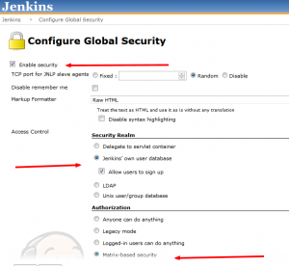](http://techieroop.com/wp-content/uploads/2014/07/Configure-Global-Security-Jenkins-2014-07-07-18-44-04.png)

You can check all CLI option in **http://<jenkins server >/cli/** ( e.g http://localhost:8080/cli/ ) page.

To access **CLI** feature in Jenkins download **jenkins-cli.jar** (http://<jenkins server>/jnlpJars/jenkins-cli.jar) and place this jar your directory or location from you are going to run jenkins build command.

Jenkins Command build Option:-

**Syntax :-**

java -jar jenkins-cli.jar -s http://<jenkins server>/ build build-name [-c] [-f] [-p] [-r N] [-s] [-v] [-w]

**Option Descriptions:-**

build-name : Name of the job to build

-c  : Check for SCM changes before starting the build, and if there's no change, exit without doing a build

-f  : Follow the build progress. Like -s only interrupts are not passed through to the build.

-p  : Specify the build parameters in the key=value format.

-s  : Wait until the completion/abortion of the command. Interrupts are passed through to the build.

-v  : Prints out the console output of the build. Use with -s

-w  : Wait until the start of the command

e.g.

java -jar jenkins-cli.jar -s http://localhost:8080/ build 'my-project-build' --username roop --password roop